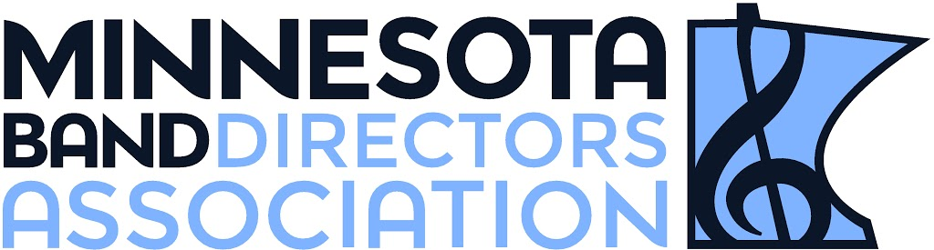
SOUTH CENTRAL REGION
November 3, 2017
Dear Instrumental Colleagues,
The 2018 South Central Minnesota Band Directors Association Honor Band will be an opportunity for talented musicians from our region to come together for a day of outstanding music making! This year we will be hosting both the 6-8 and 9-10 honor bands on Saturday, February 10, 2018 at Mankato West High School. We invite you to nominate your top musicians for this event. Because your recommendation will serve as their “audition”, we ask you to only nominate students you consider to be honor band caliber. This will ensure that all participating honor band members receive a quality experience. Please have your students and parents verify that they are available on the day of the festival BEFORE you submit your nominations. This lessens the need to find replacements for students once they are selected and music is sent out. If you would like, there is a Parent Letter template in the Google folder for you to copy and edit as needed.
We have two exceptional directors lined up for this event – the 6-8 band will be directed by Kay Hawley and the 9-10 band by Bob Goheen. Your students will most certainly benefit from their talents!
Nominations will be submitted online this year. Please click the corresponding link or cut and paste into your browser. The form has space for you to nominate 8 students--keep in mind that your first student will be considered your highest caliber student. Please provide as much pertinent information on the nomination form as possible (lesson book pages/range/other important skills to note) so we can make informed decisions during our selection process.
Online nomination forms:
6-8 Honor Band Nomination Form
9-10 Honor Band Nomination Form
You must also have your students and parents fill out the permission/medical form. All forms should be mailed to the addresses below and postmarked by December 15, 2017. If students are NOT selected, permission/medical forms will be destroyed.
To ensure that your district students have the opportunity to participate in this event please verify that all appropriate grade-level directors from your building/district (especially directors new to your district) received this e-mail as we ARE NOT sending letters by mail.
Your SCMBDA Board is looking forward to facilitating this opportunity for our regional musicians! Please don’t hesitate to contact us with any questions. We look forward to receiving your nominations!
Sincerely,
SCMBDA Honor Band Coordinators,
Gertrude Sommerfeld 9-10 Band Allie Jensen 6-8 Band
Central Middle School Forest Hills Elementary School
8025 School Road 13708 Holly Rd
Eden Prairie, MN 55344 Eden Prairie, MN 55346
gsommerfeld@edenpr.org ajensen@edenpr.org

