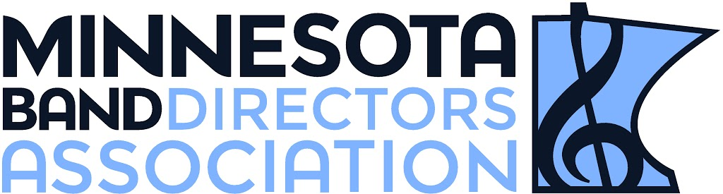
SOUTH CENTRAL REGION
November 3, 2017
Dear Band Parents,
The South Central Region of the Minnesota Band Directors Association will be hosting its annual Honor band on Saturday, February 10, 2018 at Mankato West High School. We would like to nominate your son/daughter for the group, but need to make sure that they will be able to participate if chosen. This is an all-day event, culminating in the performance in the late afternoon. It’s difficult to find replacements once the band is selected. If you could please check your calendar to see if this is a workable date, we would be able to ensure the commitment of our students. We can’t guarantee that all nominees from (ENTER YOUR SCHOOL NAME HERE) will be accepted, but we are hopeful to have several students involved in the event.
The fee for participation in this honor band is $35. This will be collected AFTER students are chosen for the honor band. This fee covers cost of lunch the day of the honor band, a t-shirt for your student, and the costs of music, and guest conductors and section coaches to work with your students throughout the day.
Please sign and return the attached permission/emergency form. If your child is not chosen for the honor band all forms will be shredded.
Form and Check must be returned to your child’s band director no later than December 8th, 2017.
Thank you for your time and help!
We look forward to working with you student in February!
Sincerely,
(ENTER BAND DIRECTOR NAME HERE) and the South Central MBDA Honor Band Chairs

Be sure that you have given the following to your band director by December 8th, 2017.
_____ Permission/Emergency Form
_____ $35 Check - Payable to MBDA

